To whom it may concern:

I am writing this letter to highly recommend using Rose of the Heart Association as an adoption partner. We adopted our son from Bulgaria in 2020 amidst Covid-19. From the beginning of our adoption through the finalization, Mariana and her team were beyond anything we could have dreamed of in an adoption agency. They were helpful, professional, and extremely kind. Our experience from start to finish was phenomenal and we have, and will continue, to recommend families to complete adoptions with them. Specifically, the team worked with efficiency and dedication to our family and to the children of Bulgaria. They were inviting and helpful in country by accommodating all of our needs while ensuring all safety and legal measures were followed.

Our family will always be grateful to Rose of the Heart for helping us bring our son home, and we will, without a doubt, choose to use their agency for any future adoptions from Bulgaria while also recommending them to everyone.

Kindly,
The Odegaard Family
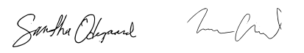
Samantha and Aaron
9204 S. High Meadows Drive
Black Hawk, SD 57718
adsaodegaard@gmail.com

